Project Summary – SLAM – A Shared Learning Repository For Advanced Manufacturing
The goal of this project is to develop a learning repository for creating customizable teaching environments. The repository will contain modular educational materials for manufacturing instruction to be used by multiple educators, where each instructor retrieves text and video components for specific topics along with other course material specifically related to his/her course. A typical technology instructor will modify and embellish these materials to meet their individual instructional needs. The difference is that the instructor then redeposits these materials back into the repository to create “organic educational materials” that grow and are enriched over time by use for Advanced Manufacturing (AdM) instruction.
This project builds onto information gained from an NSF Workshop Project (NSF DUE-1841441), where Advanced Manufacturing Instructors attended three workshops and identified roadblocks to developing and managing shared learning materials. Through this project, we found that the repository should reduce the student cost and faculty development time for courses. We saw our prototype repository serving the rapid deployment of new advanced manufacturing topics, and also facilitating new delivery methods such as those COVID-19 brought us.
Focus sectors were developed during the early workshop project to include the following topics and Lead Researchers: Traditional Manufacturing Methods (Wysk), Foundry Methods (Voigt and Lynch), Additive Manufacturing Methods (Harrysson and Timmer), Hybrid Manufacturing (Manogharan), Design for Production (Kremer), Composites Engineering (Liang and Okoli) and Manufacturing Control (King). Our goal is to take the knowledge and community developed during the Workshop Project forward to complete this repository. We will then measure: 1) the student learning outcomes, and 2) the student/faculty perspectives concerning this new flexible, affordable and expandable collection of learning materials.
Intellectual Merit: Engineering education will improve by continuing to 1) develop and evolve a set of public AdM-related course materials (chapters, exercises/labs, videos, presentations), 2) identify both teaching and development needs in the AdM area, 3) develop a comprehensive set of chapter, lecture, video, computer lab, and small-group materials so that distance/virtual education, traditional learning and “flipped learning” can be used in this critical area, 4) use the curricular material authoring, evaluating and disseminating as a community-building tool so that events like COVID 19 can be more easily overcome, 5) establish practices to ceate fair use of material and sustainability, and 6) create an educational network that can partner in this critical area.
Broader Impacts: The major broader impact of this work will be enhanced AdM education of engineering students facilitated by the resulting repository. Most importantly, our early evidence suggests that the learning outcomes from using materials and methods developed as part of this project will significantly improve the outcomes of using the current textbook model. Because materials can be easily altered to include specific AdM software, hardware and illustrations at given locations, the learning will more closely parallel local/regional needs and constraints. Local/regional or industry segment examples can be brought directly into the class materials to make students relate more closely to them. Finally, we feel that this shared educational resource will improve instructor productivity by avoiding “reinventing the teaching wheel.” Normally, new instructors do not have significant industrial experience and could benefit from a repository that includes experiences shared by more seasoned instructors.
Background Most engineering faculty spend numerous hours building materials and presentations for their courses, even if these courses are traditional engineering topics. New faculty work many hours building their own teaching repository of materials that include: good engineering examples that illustrate specifc engineering concepts, slides to facilitate conveying these concepts, homework that is used to reinforce specific concepts, developing testing materials. This process is a long-established procedure for new faculty.
The current pandemic cast the proverbial “curve-ball” on teachers everywhere. Technology instructors found their materials were tailored to a specific teaching environment and spent endless hours restructuring the materials. In many instances, the outcomes both learning and appreciation/enjoyment of the materials and methods (for both students and faculty were diminished. The personal teaching repository previously developed was not particularly flexible.
This proposal focuses on the development and use of a teaching repository for advanced manufacturing technology that will facilitate both teaching development and student learning. The repository can be used during traditional times, but will also be especially useful in difficult times like the recent world pandemic. Our repository houses a variety of teaching materials that instructors can access for their class, and change these materials to better fit their class needs and style. The “catch” is that they must share their newly developed materials by submitting them back to the repository for reuse. The result is that the materials will grow over time, and stay more current. We call this repository SLAM for Shared Learning for Advanced Manufacturing. We feel that we have created an “open architecture” concept for course development and preparation along with a community of instructors that are willing to utilize this resourse.
Introduction We seek support for an NSF Institutional and Community Transformation grant (level 2) to continue to grow the “Community for Advanced Manufacturing Learning” (CAML) developed as part of a Workshop Grant Award (DUE- 184132) where some 70 instrutors of Advanced Manufacturing Technology interacted at three workshops held from May 2019 until October 31, 2020. These instructors represent 24 different academic institutions. During the course of our workshop grant, the CAML group was affected adversely by COVID 19, and many sought help in developing remote materials for their course assignments. During this time Dr. Richard Wysk shared his course notes and materials for his ISE316 Manufactuing Engineering I course. Although the learning repository was of a raw form (housed first on NC State Moodle Teaching system and then on a student generated Wordpress site at NC State), it did serve about a half dozen instructors that were trying to reorganize their course activities.
The intent is that the repository will serve as the foundation for the Community of Advanced Manufacturing Learning. This repository/foundation will provide text chapters, quizzes, test, problems and examples that can be used in the development of AMT courses. The service will be free and most materials on SLAM will be Open Source materials that users can readily modify and improve.
As an NSF IUSE Institutional and Community Transformation proposer, we seek to unite multiple universities utilizing a learning repository as a shared platform. The idea of Open Source Educational materials is not new, but has never grown as expected. We feel that we have the ideal opportunity to advance manufacturing education across the U.S. Because the scope of Advanced Manufacturing Technoloy (AMT) is broad and integrative in nature, we will focus on creating both practice-based instructional materials and demonstration-based instructional materials. During our Workshop Project, we developed a community (CAML) that will serve as the foundational contributors and application test sites for the work outlined in this proposal using this “open architecture”.
Two similar repositories in engineering have been discovered: 1) LearnChemE, at the University of Colorado [http://www.learncheme.com/home] and 2) MedEd [https://onlinemeded.org/], supported by the American College of Physicians. MedEd provides the most sucsinct story of their orgin, “Med school sucked. Information was needlessly overworked and extraneous, materials were expensive, and the sources were disjoined and scattered. We got the job done and did well, but knew there had to be a better way. We had the knowledge, skill and scores to do it. So we went to work; we got a white board, a camera, and started making videos. It worked. People used it. People LIKED it. Our interest is in making better doctors, which is why our videos are and always will be free. But we wanted to reach more people and be more than just a cool video site only a handful of people knew about. “ This is the focus of Shared Teaching materials for Advanced Manufacturing or SLAM. The Chemical Engineering project provides a closer domain example of encouraging an engineering community to provide more up-to-date instructional modules for basic engineering materials.
Methodology It is our intent to use Open Education Digital Tools to continue the development of SLAM. Open Education is a topic that has received significant attention and funding across the US. The Open Education community has advanced more sophisticated development tools ,like Creative Commons [https://creativecommons.org/about/], OER Commons [https://www.oercommons.org/hubs/oenc] and Geneseo [https://oasis.geneseo.edu/index.php]. It is our intent to utilize these tools to continue and build onto our early web repository. These tools focus on Open Education and Digital Materials that can be easily and inexpensively stored.
The early repository benefits from the generosity of a number of people. Two of these people, Drs. Richard Wysk and Ola Harrysson, have contributed their teaching materials to SLAM for use in advanced manufacturing technology. Dr. Wysk is a well-know educator for Computer Aided Manufacturing with more than 40 years of university experience. He donated chapters accociated with traditional manufacturing engineering methods to SLAM (more than 15 chapter-like volumes). Dr. Harrysson is one of the founders of Additive Manufacturing (AM) technologies. He and his students donated 10 chapters focused on engineering using AM for the production of commercial components. These materials are already available and will become the foundation for a more comprehensive SLAM repository.
Specific focus sectors were developed during the early workshop project to include the following topics and lead researchers:
- Traditional Manufacturing Methods (Richard Wysk and Paul Cohen),
- Foundry Methods (Robert C. Voigt and Paul Lynch),
- Additive Manufacturing Methods (Ola L.Harrysson and DouglasTimmer),
- Hybrid Manufacturing (Guha Manogharan and Thorsten Wuest),
- Design for Production (Gul Kremer and xxx),
- Composites Engineering (Richard Liang andOkenwa Okoli) and
- Manufacturing Control (Russell King and xxx).

Our goal is to take the community developed during the Workshop Project with the defined areas to complete this repository. We will measure: 1) the student learning outcomes, current and with SLAM; 2) the student andfaculty learning perspectives concerning this new flexible, affordable and expandable collection of learning materials, student and faculty experiences with the materials, and 3) Student learning outcomes as a function of the breadth and depth of course topics and materials, some early manufacturing courses focus on a broad set of manufacturing methods, while others look to obtain a deeper understanding of specific processes.
The Intellectual Merit of SLAM’s use in Engineering education will primarily come from an “open educational materials” concept that will be made available both during learning education and also after during engineering practice. We envisage this open education providing components to: 1) develop and evolve a set of public AMT-related course materials (chapters, exercises/labs, videos, presentations), 2) identify both teaching and development needs in the AMT area, 3) develop a comprehensive set of learning materials so that self-learning, distance/virtual traditional learning and “flipped learning” can be used in this critical area, 4) use the curricular material authoring, evaluating and disseminating as a community-building tool so that events like COVID 19 can be more easily overcome, 5) establish practices for fair use of SLAM material and sustainability, and 6) create an educational network that can partner in this critical area.
The functional operation of SLAM is shown in Figure 1. The fugure shows the “Materials Acquisition Process” as well as the “The materials User Process”. The Data Plan and Repository Manager will oversee the entire system. The Technology Manager will serve as “Editor” for acquisitions reviewing the materials and recommending modifications until the materials is considered of appropriate content and quality for SLAM.
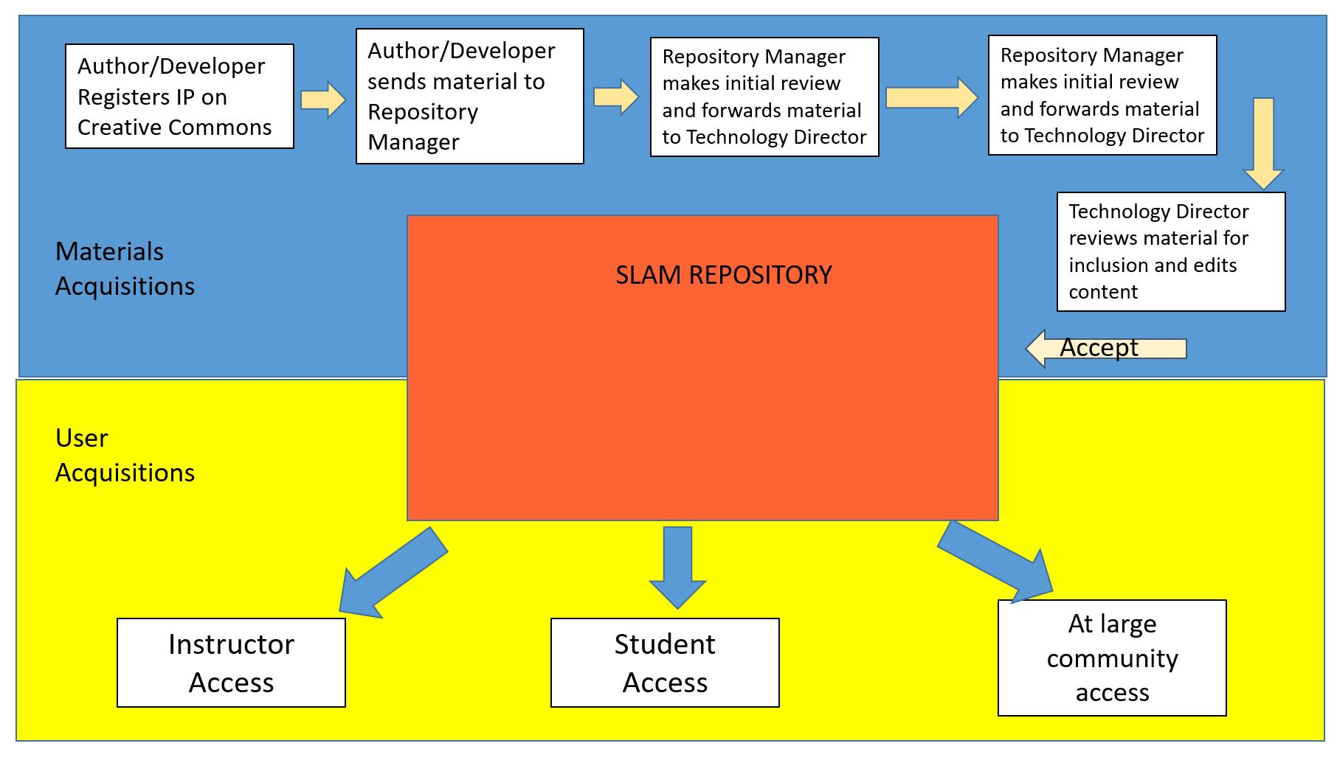
Figure 1. SLAM Functional operation.
Educational Plan (Paul Lynch and Gul Kremer), We plan to develop a repository that will assist in the student learning and the Instructor preparation of AdM courses. The Educational Plan for such an endeavor is broad and multifaceted in many ways making this project different than most IUSE activities. As an Institutional and Community Transformation proposal, we are looking to transform how the AdM community will offer engineering courses and provide a resource that will become a “Must Use” component of AdM education.
In the past, objectives like: 1) Student learning preferences [Lynch et al 2014a], 2) Real life applications [Lynch et al, 2014b], 3] Workforce skills development [Lynch et al 2015], 4) Active Learning or Interact, Cultivate and Deliver (ICD) [Lynch 2016a], 5) Finding and filling skills gaps [Lynch et al 2016c] and 6) Designing courses for maximum student engagement were investigated scientifically to measure both student learning outcomes as well as student satisfaction. These objectives will certainly be utilized and investigated as part of this work. However because of the broad nature of this activity, part of our education plan will be to measure the type and quantity (hits) of use and development that SLAM facilitates. Getting the community to use SLAM will be one of the principle objectives of this project.
The breadth of AdM activities makes creating a comprehensive repository an impossibility, thus we have defined the first 7 topical areas. Web will seek knowledge in the development of how introductory and follow-on courses are designed.
This needs to be continued and refined because it is the “What’s new?” in all that we’re proposing. We need to define how we monitor the site; how we’re involved in the educational use; how we measure some of these metrics; and where we will present the results.
[~2.5 pages of text and figures/tables}
Technical Plan (Guha and Thorsten, Can you take on how Technologies will be continually renewed by using Focus sectors and Lead Researchers to solicit and review materials. These folks will act much like “editors” for journals. They will maintain an active list of contributors and log uses through the website) [You have ~ 2 pages to get this done including figures and tables].
Administrative Plan (Rick Wysk and Rusty King) ~ 1.5 pages
Data Plan and Repository Management (Binil Starly and Justin Lanchaster) ~ 1.5 pages
Conclusions and Next Steps
References (I have used almost all url references. We do need to compile a comprehensive list of references/bibliography here. Add for each section)
BUDGET (Rick Wysk and Rusty King)
NSF Bios (All)

